**VISVESVARAYA TECHNOLOGICAL UNIVERSITY**

**“JnanaSangama”, Belgaum -590014, Karnataka.**



**LAB REPORT**

**on**

**Object Oriented Java Programming (23CS3PCOOJ)**

***Submitted by***

**CHETHAN T M (1BM23CS076)**

***in partial fulfillment for the award of the degree of***

**BACHELOR OF ENGINEERING**

***in***



**COMPUTER SCIENCE AND ENGINEERING**

**B.M.S. COLLEGE OF ENGINEERING**

**(Autonomous Institution under VTU)**

**BENGALURU-560019**

**Sep-2024 to Jan-2025**

**B.M.S. College of Engineering,**

**Bull Temple Road, Bangalore 560019**

(Affiliated To Visvesvaraya Technological University, Belgaum)

**Department of Computer Science and Engineering**



**CERTIFICATE**

This is to certify that the Lab work entitled “Object Oriented Java Programming (23CS3PCOOJ)” carried out by **CHETHAN T M (1BM23CS076),** who is bonafide student of **B.M.S. College of Engineering.** It is in partial fulfillment for the award of **Bachelor of Engineering in Computer Science and Engineering** of the Visvesvaraya Technological University, Belgaum. The Lab report has been approved as it satisfies the academic requirements in respect of an Object Oriented Java Programming (23CS3PCOOJ) work prescribed for the said degree.

|  |  |
| --- | --- |
| Lab faculty Incharge Name  Assistant Professor  Department of CSE, BMSCE | Dr. Jyothi S Nayak  Professor & HOD  Department of CSE, BMSCE |

**Index**

|  |  |  |  |
| --- | --- | --- | --- |
| **Sl.**  **No.** | **Date** | **Experiment Title** | **Page No.** |
| 1 | 24/09/2024 | Lab-1 | 4-8 |
| 2 | 08/10/2024 | Lab-2 | 9-13 |
| 3 | 15/10/2024 | Lab-3 | 14-19 |
| 4 | 22/10/2024 | Lab-3 | 20-27 |
| 5 | 29/10/2024 | Lab-5 | 28-36 |
| 6 | 12/11/2024 | Lab-6 | 37-43 |
| 7 | 19/11/2024 | Lab-7 | 44-48 |
| 8 | 26/11/2024 | Lab-8 | 49-51 |
| 9 | 03/12/2024 | Lab-9 | 52-58 |
| 10 | - | - | - |

Github Link:

https://github.com/Chethushub/OOJ-Lab

**Program 1**

Algorithm:

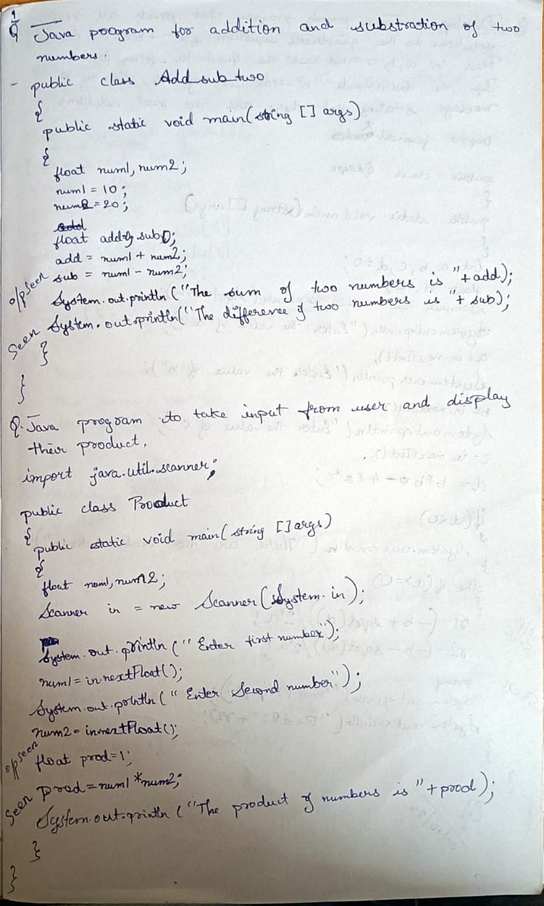

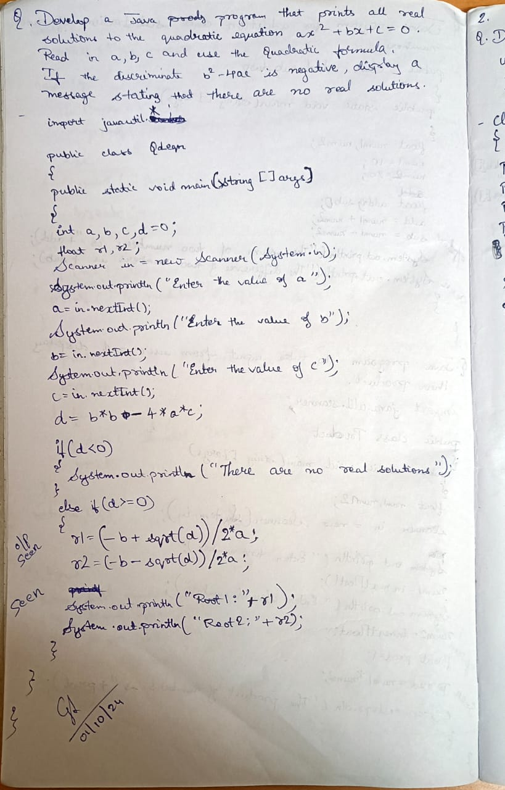

Code: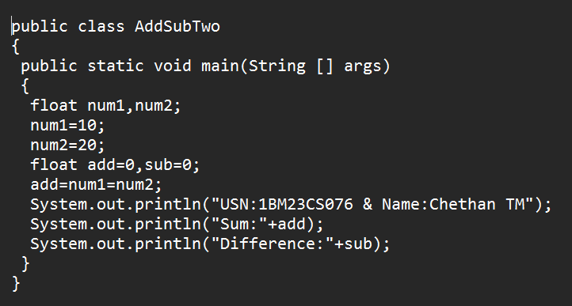

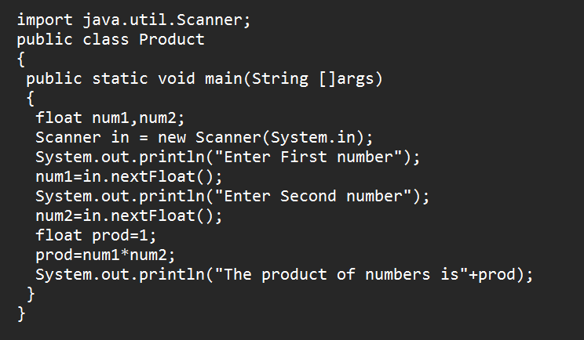

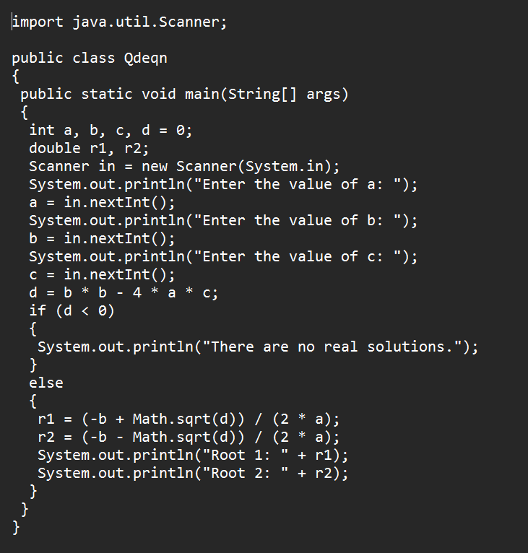

Output:

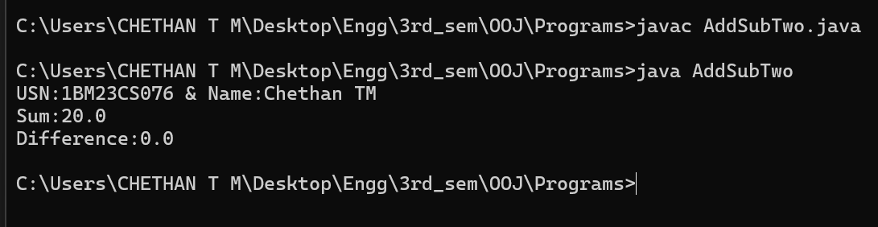

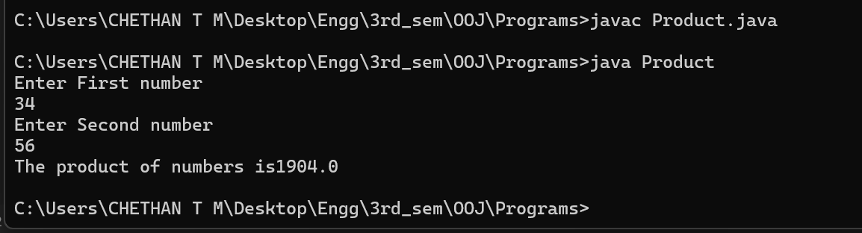

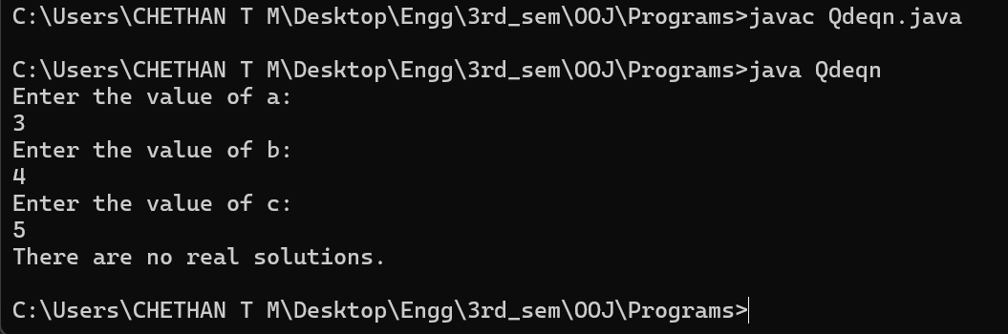

Program-2:

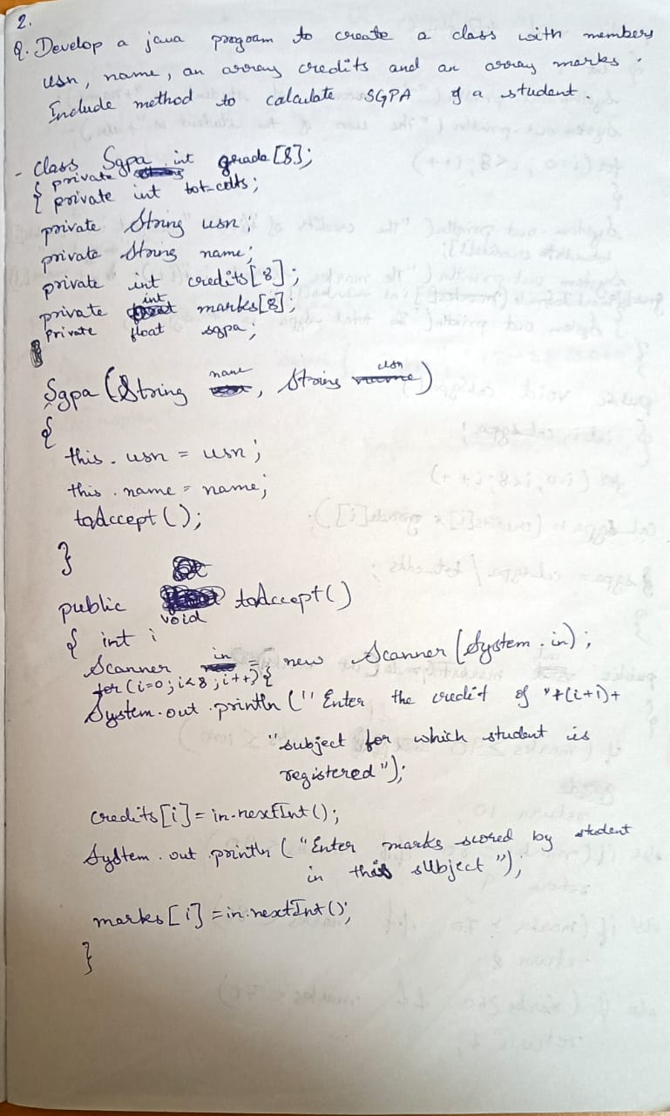

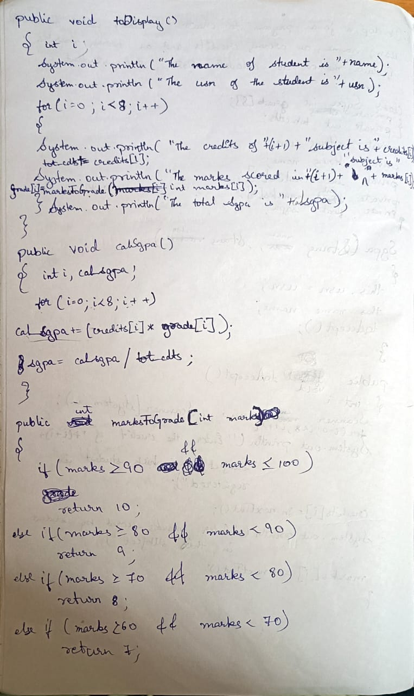

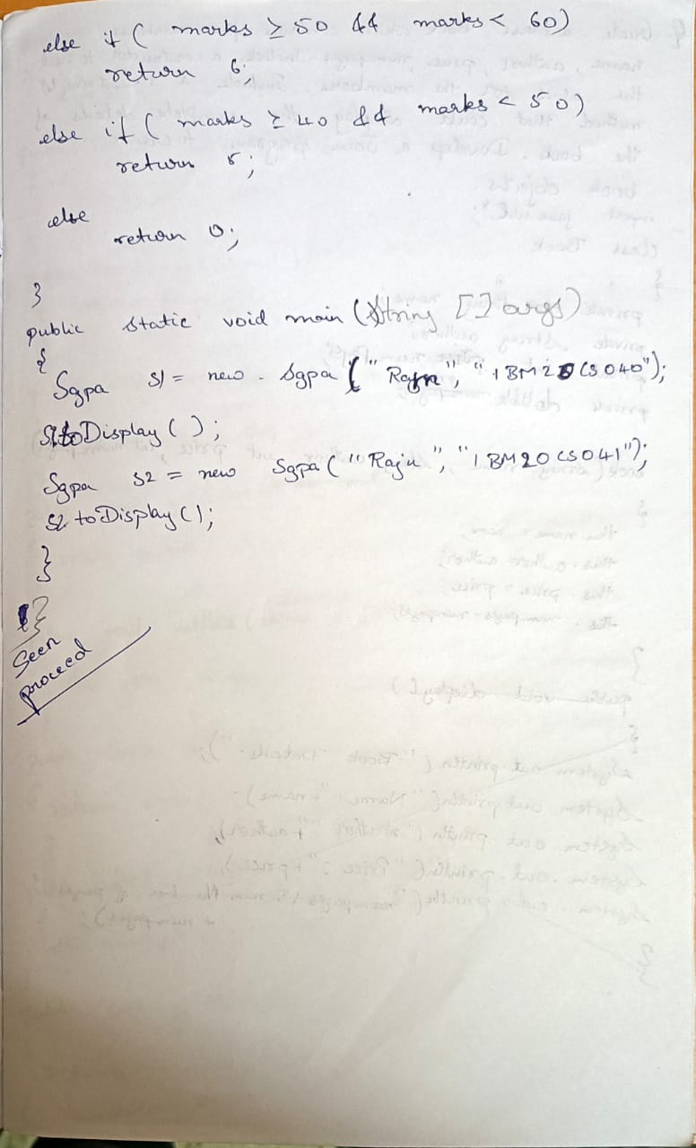

Screenshot:

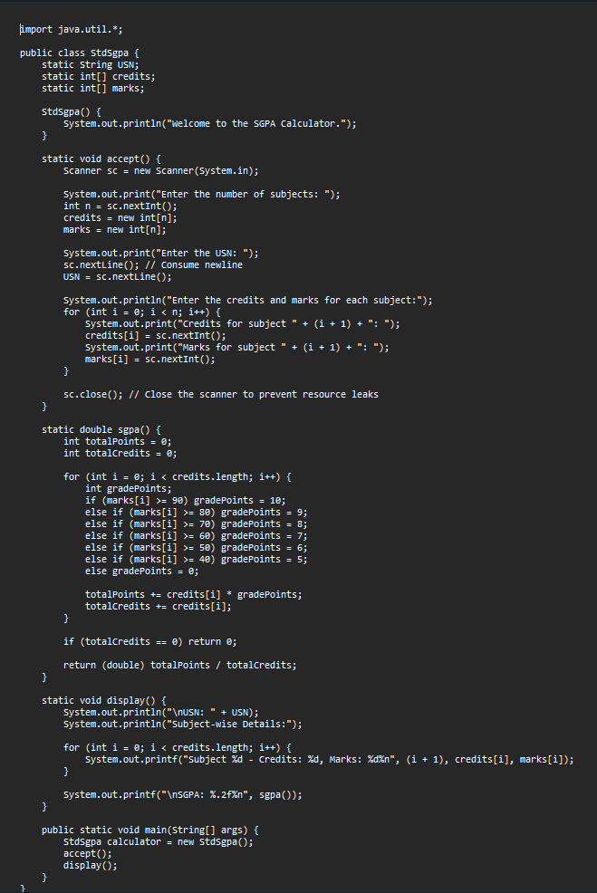

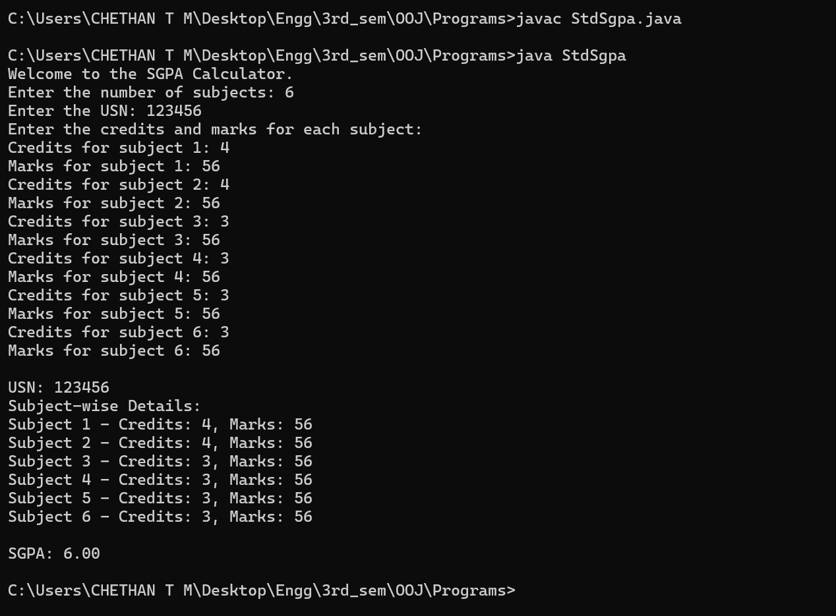

Program-3:

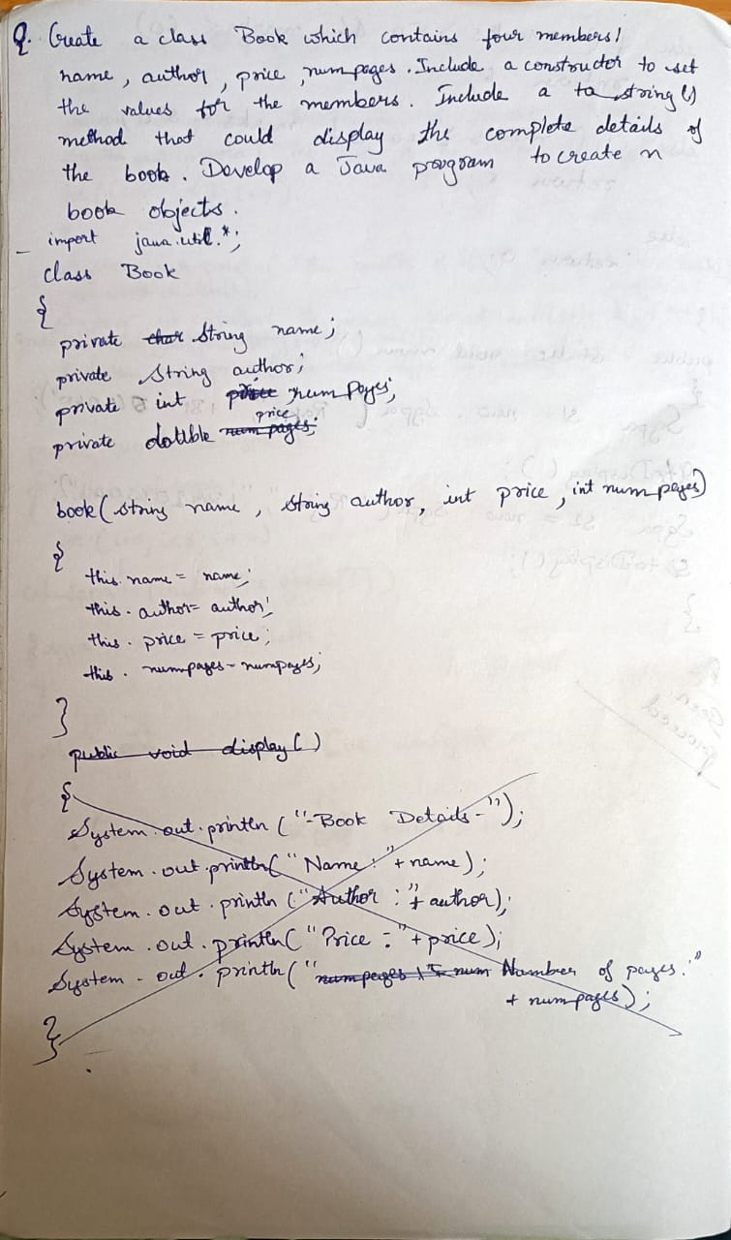

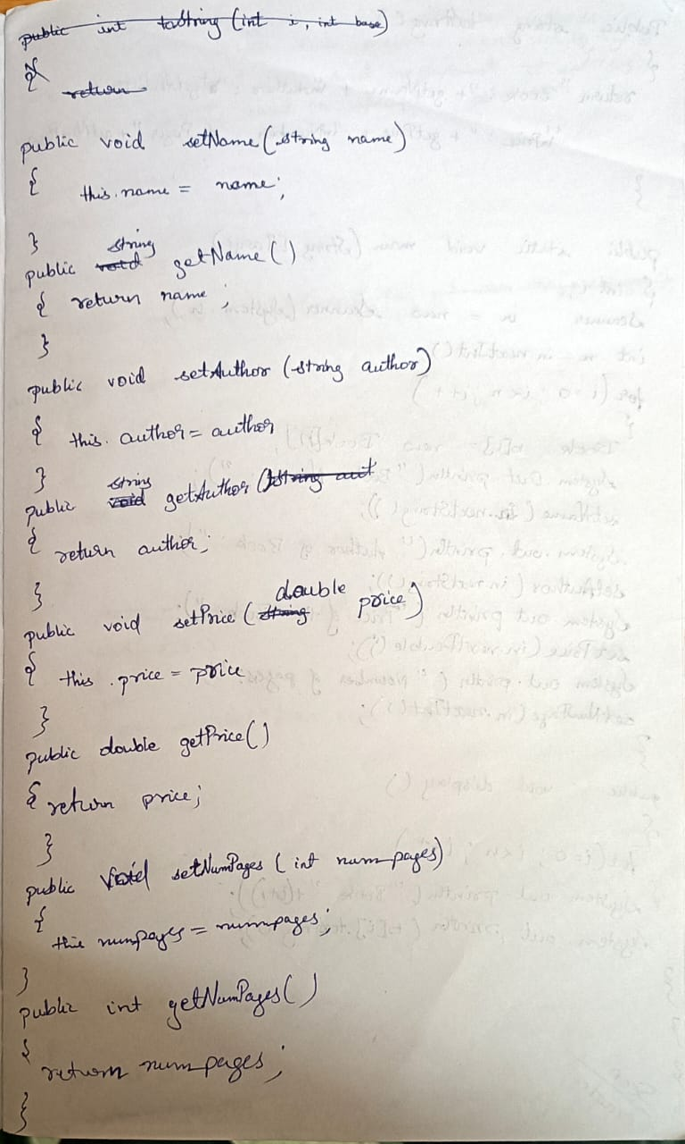

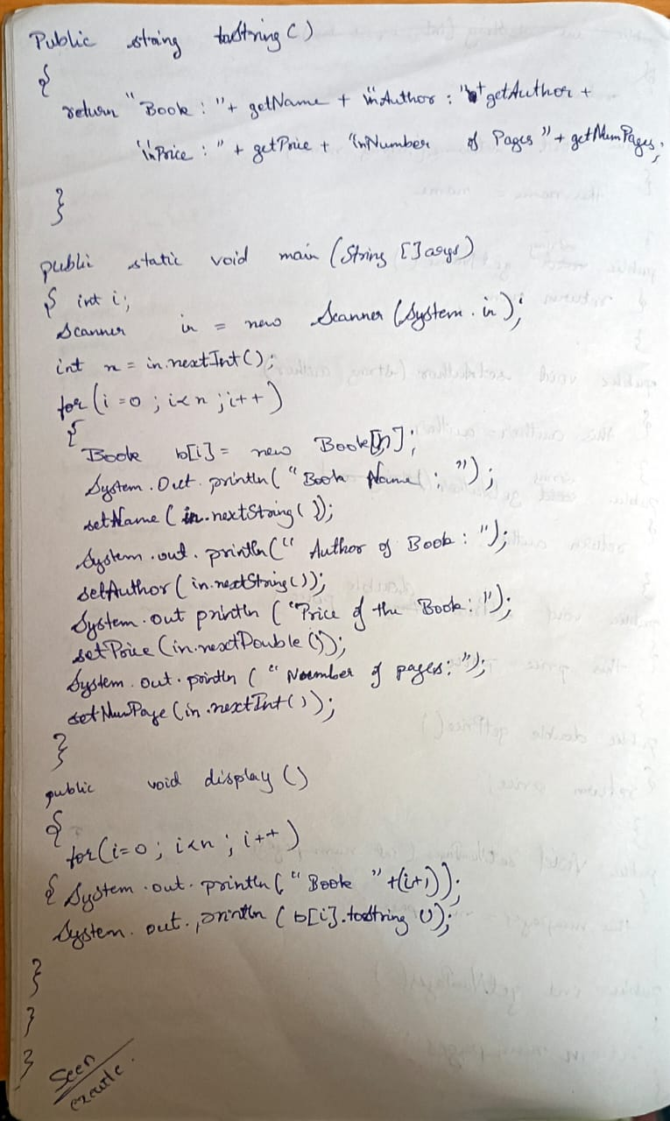

Screenshot:

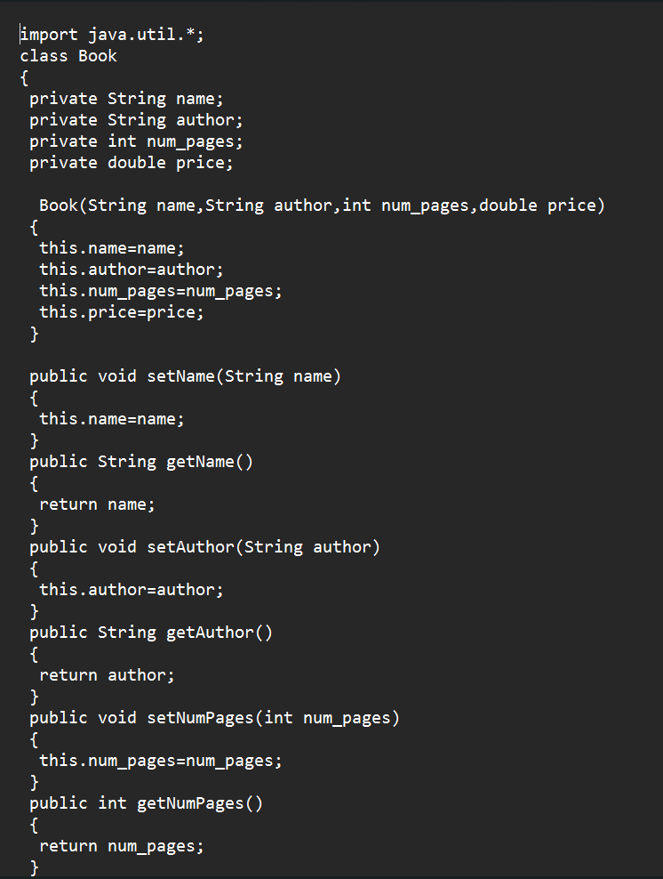

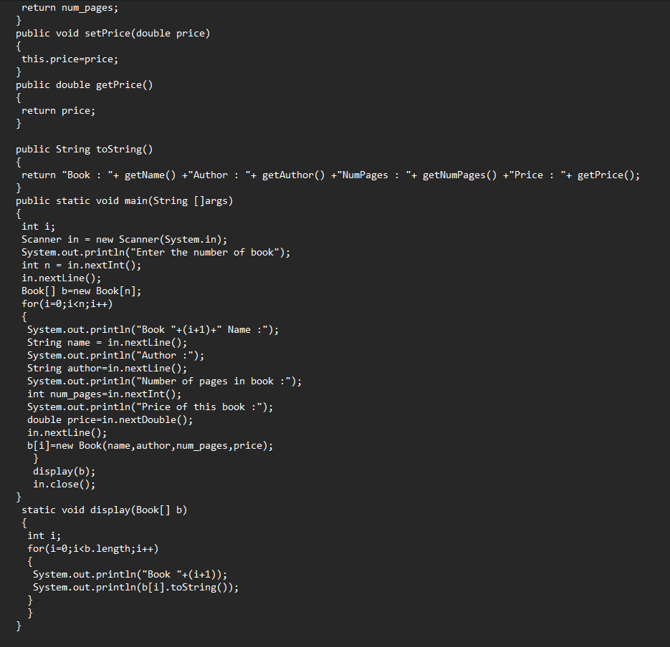

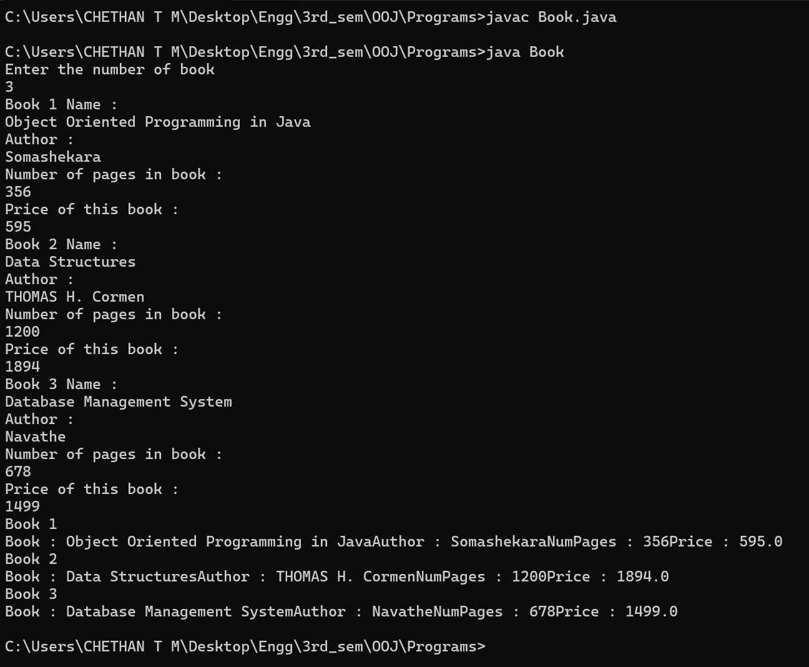

Program-4:

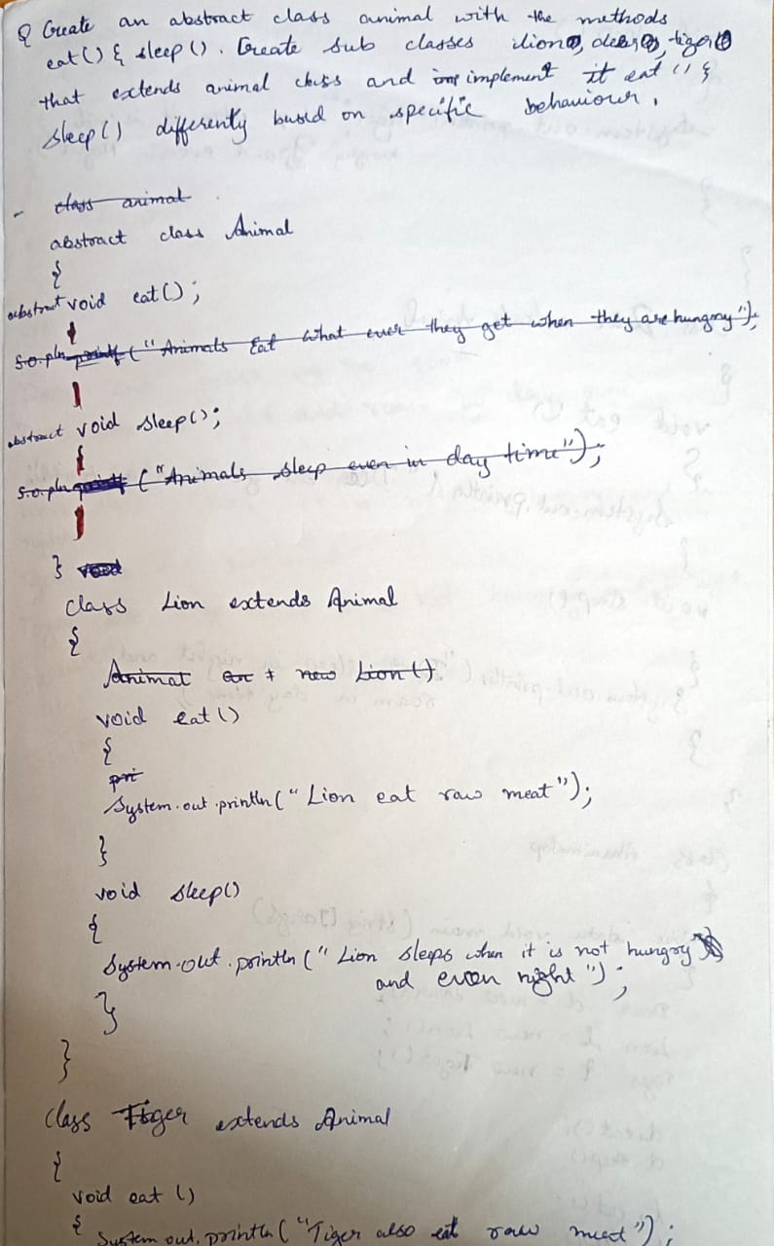

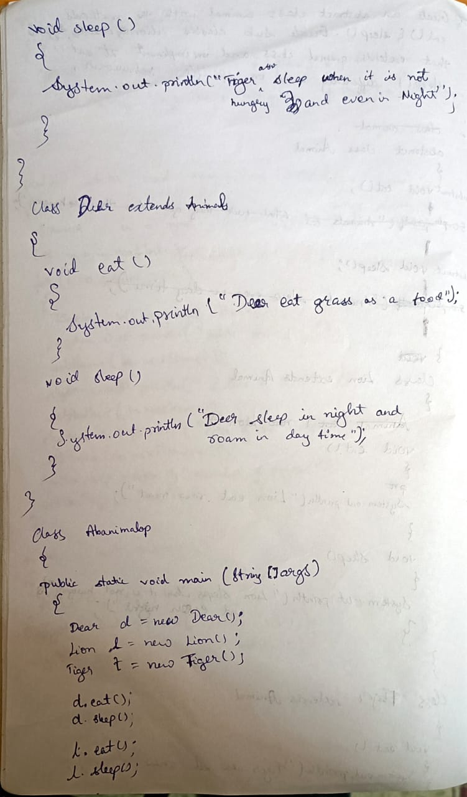

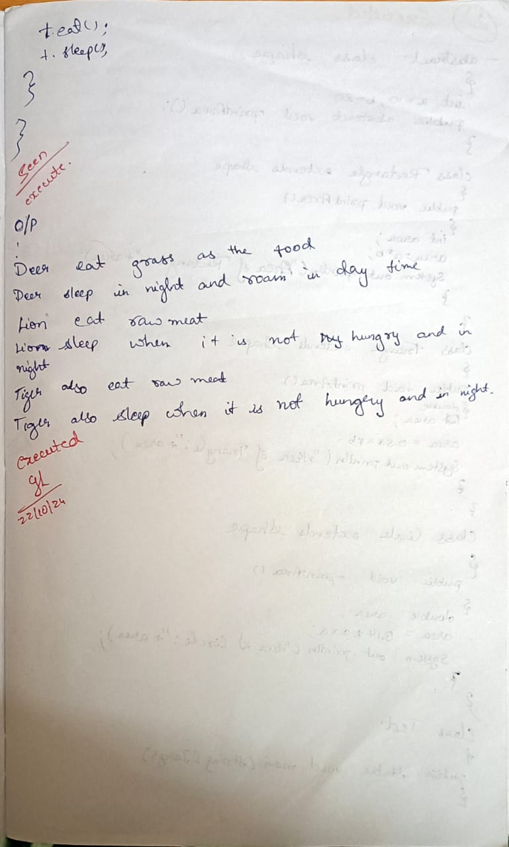

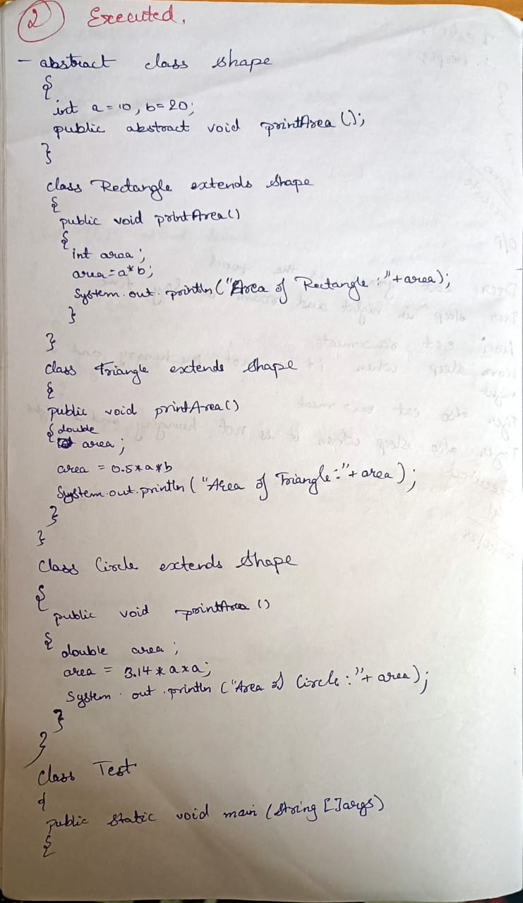

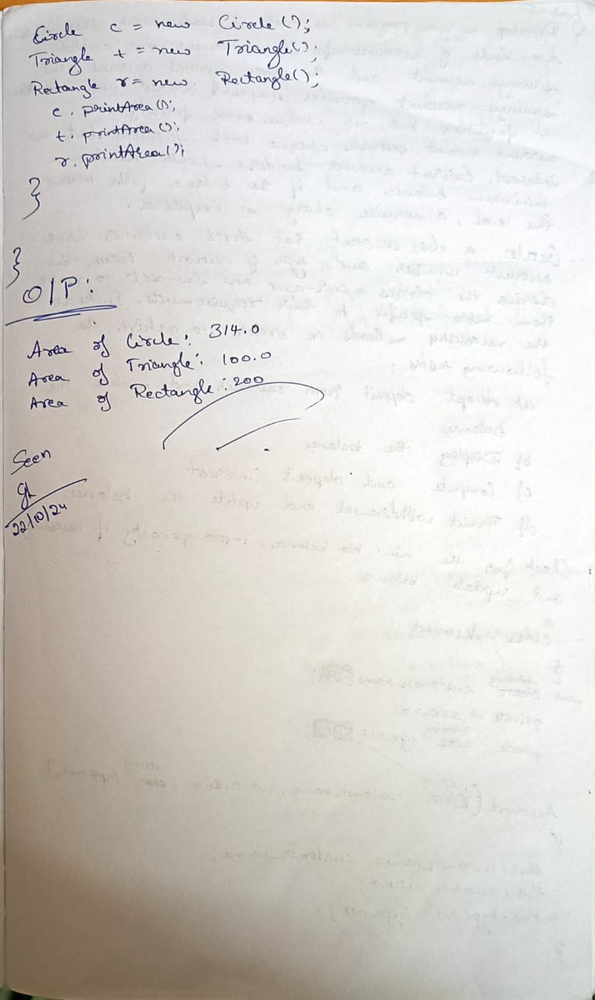

Screenshot: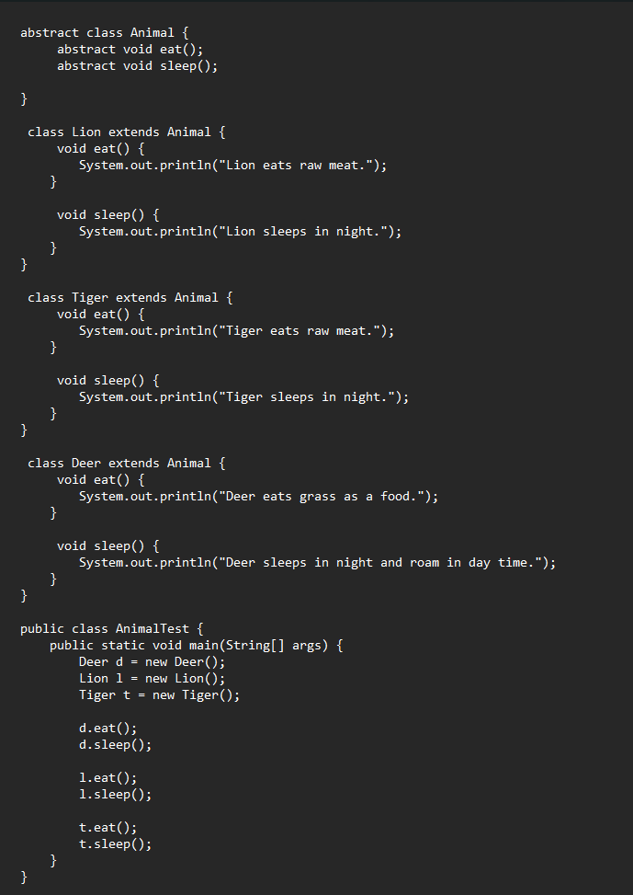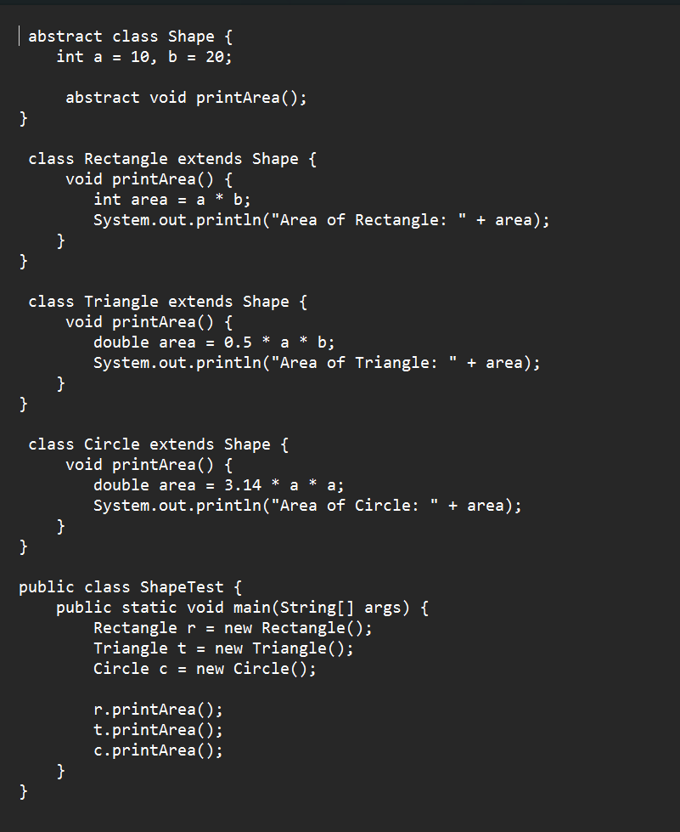

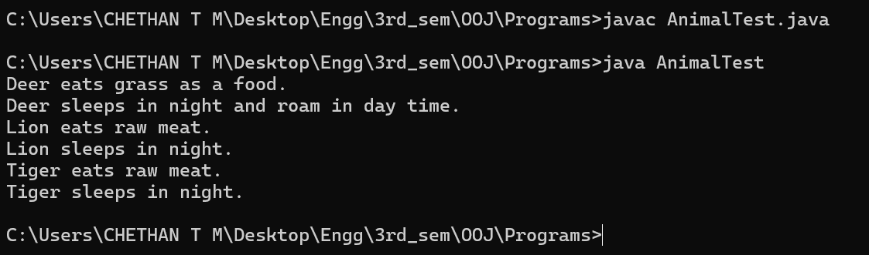

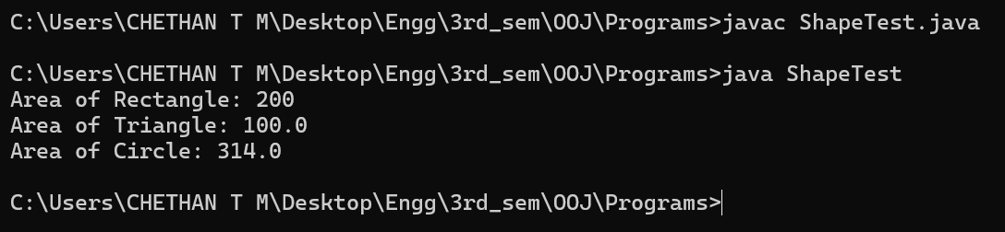

Program-5:

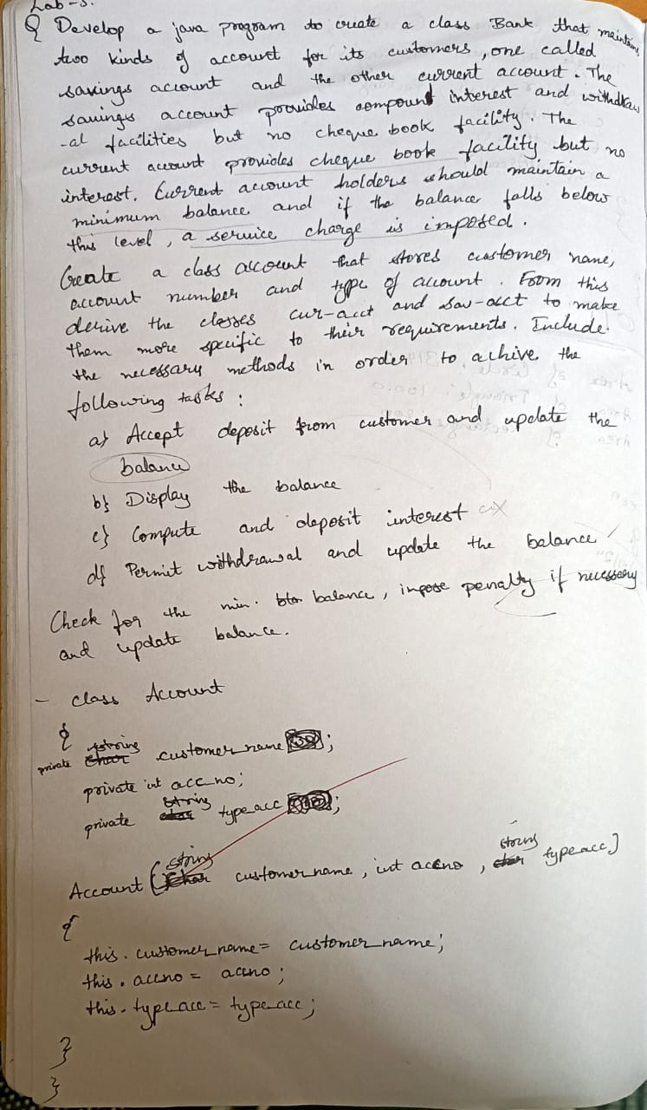

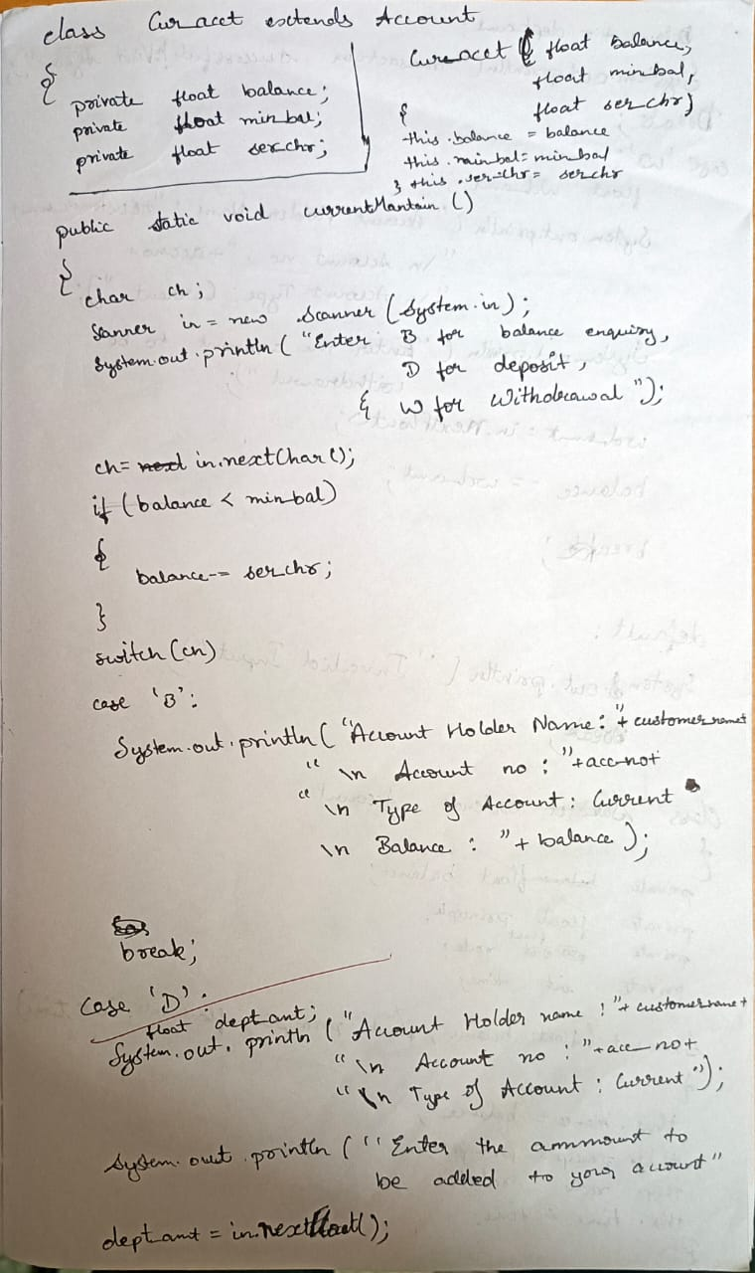

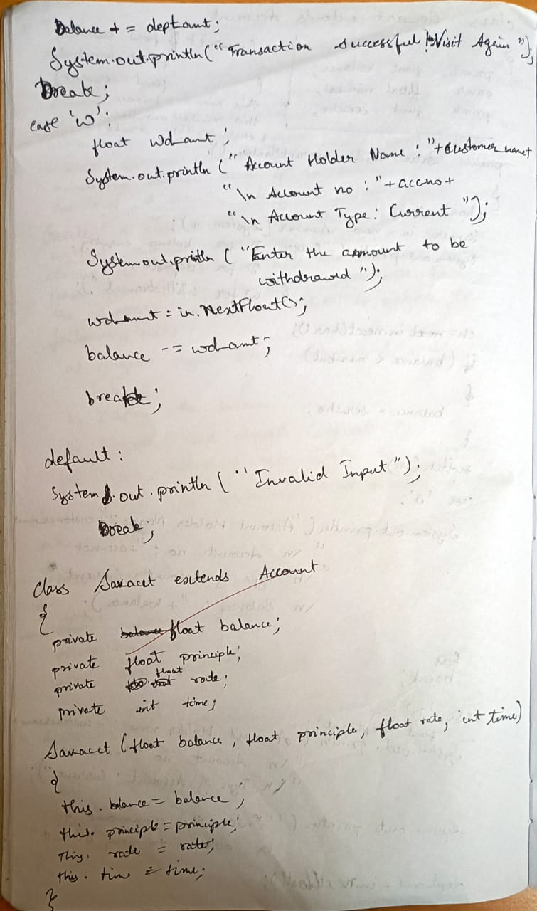

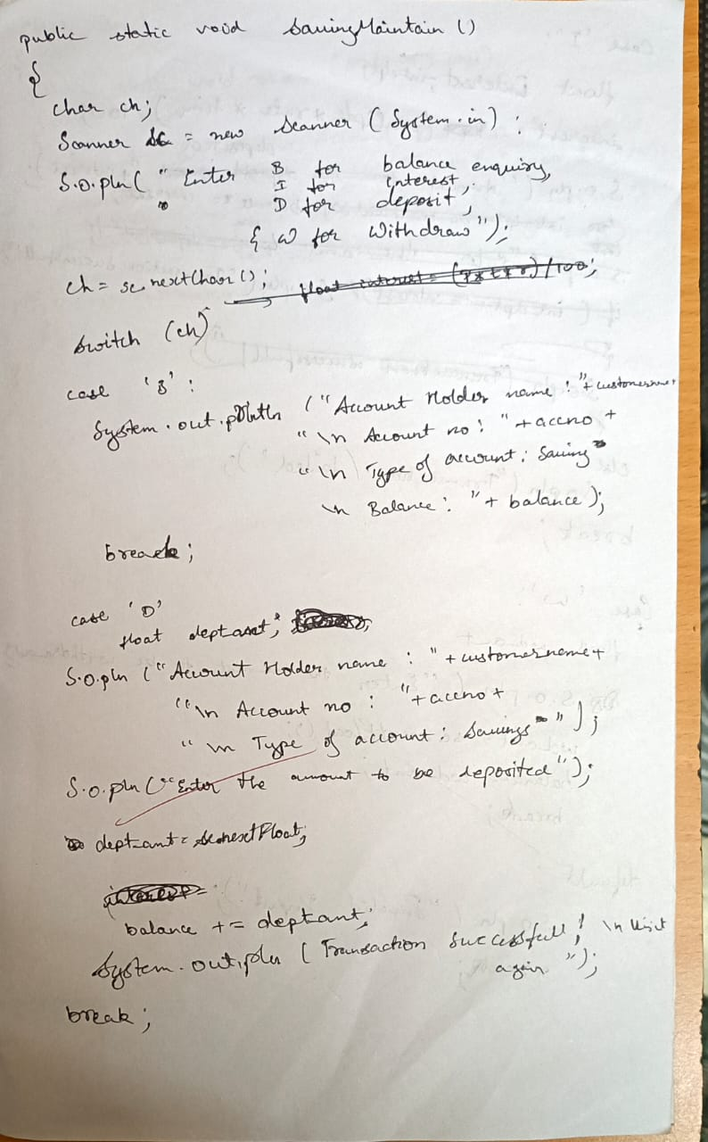

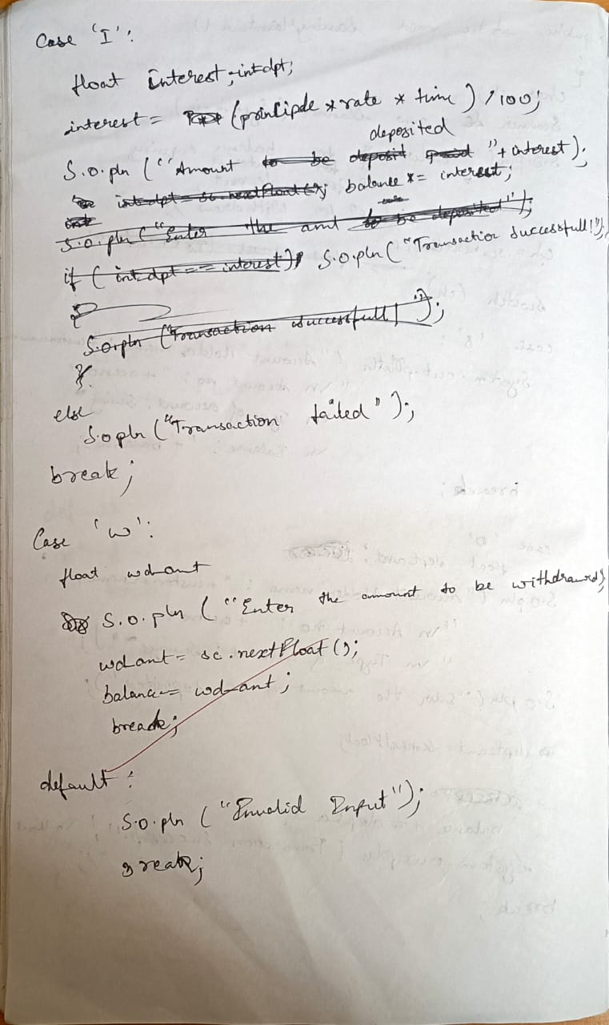

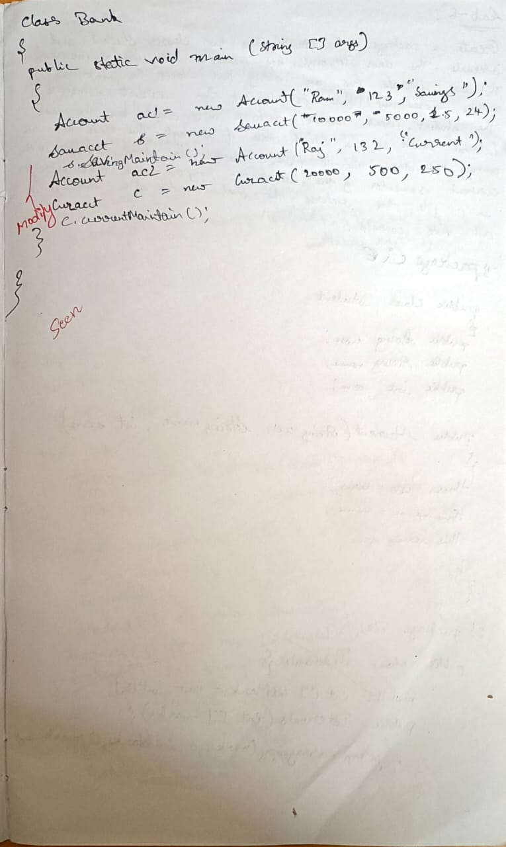

Screenshot: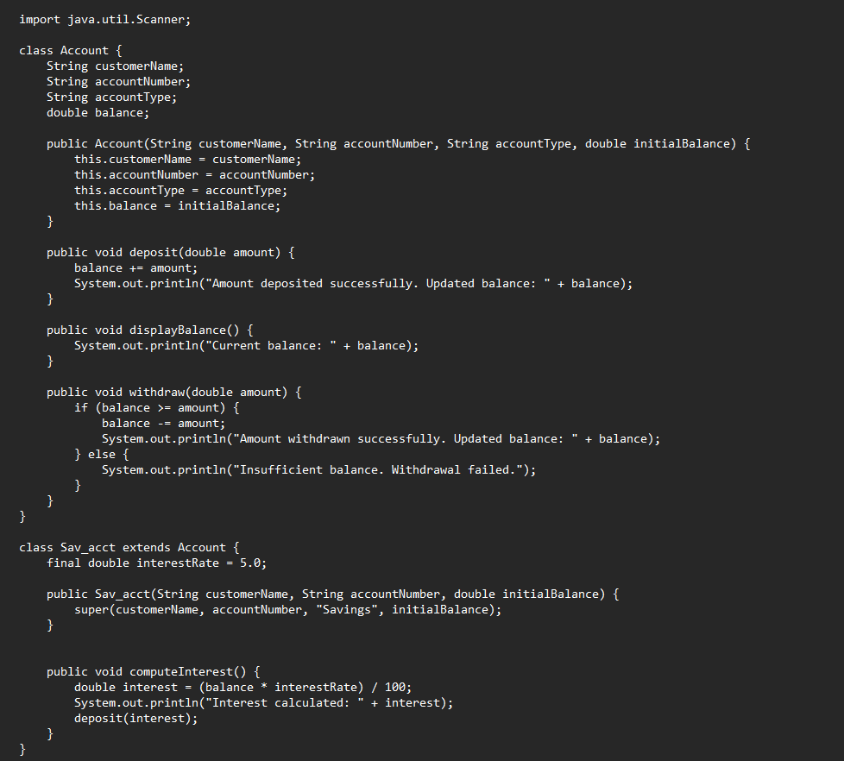

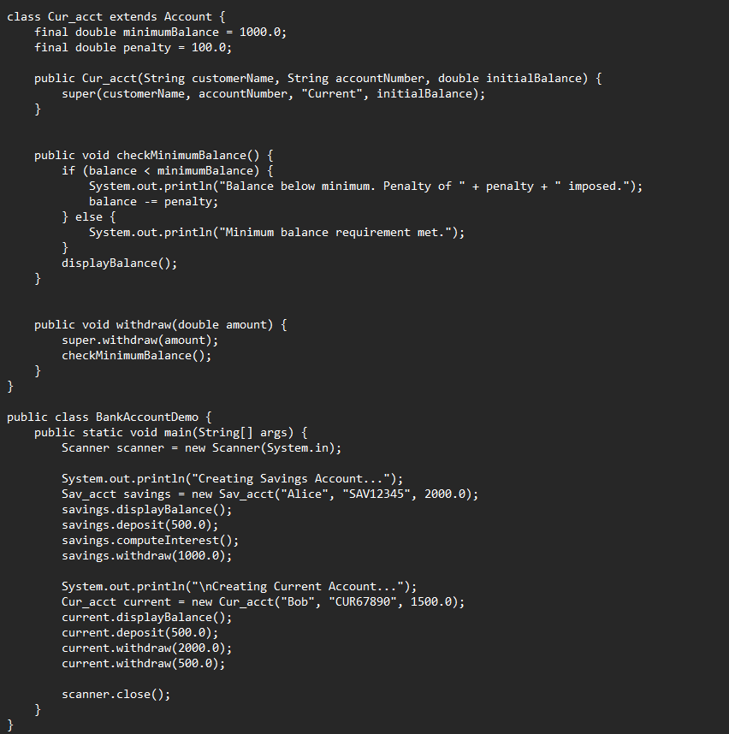

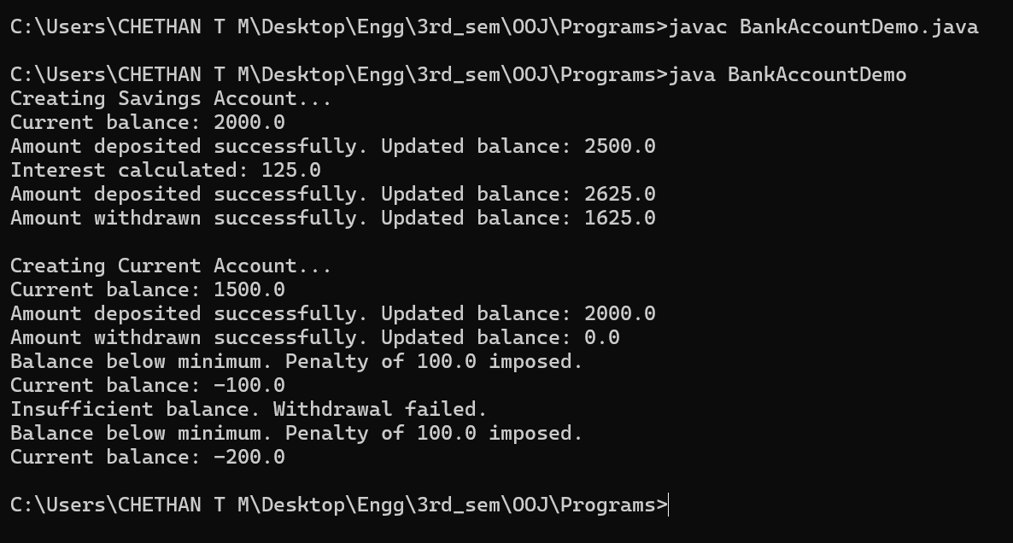

Program-6:

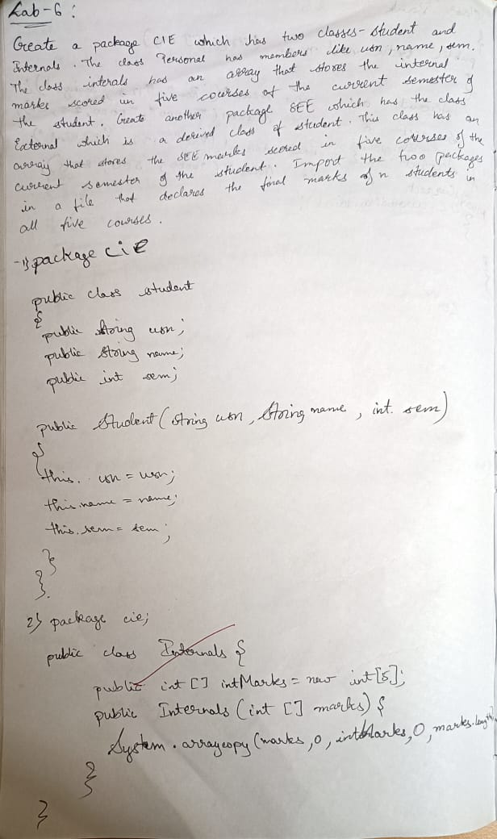

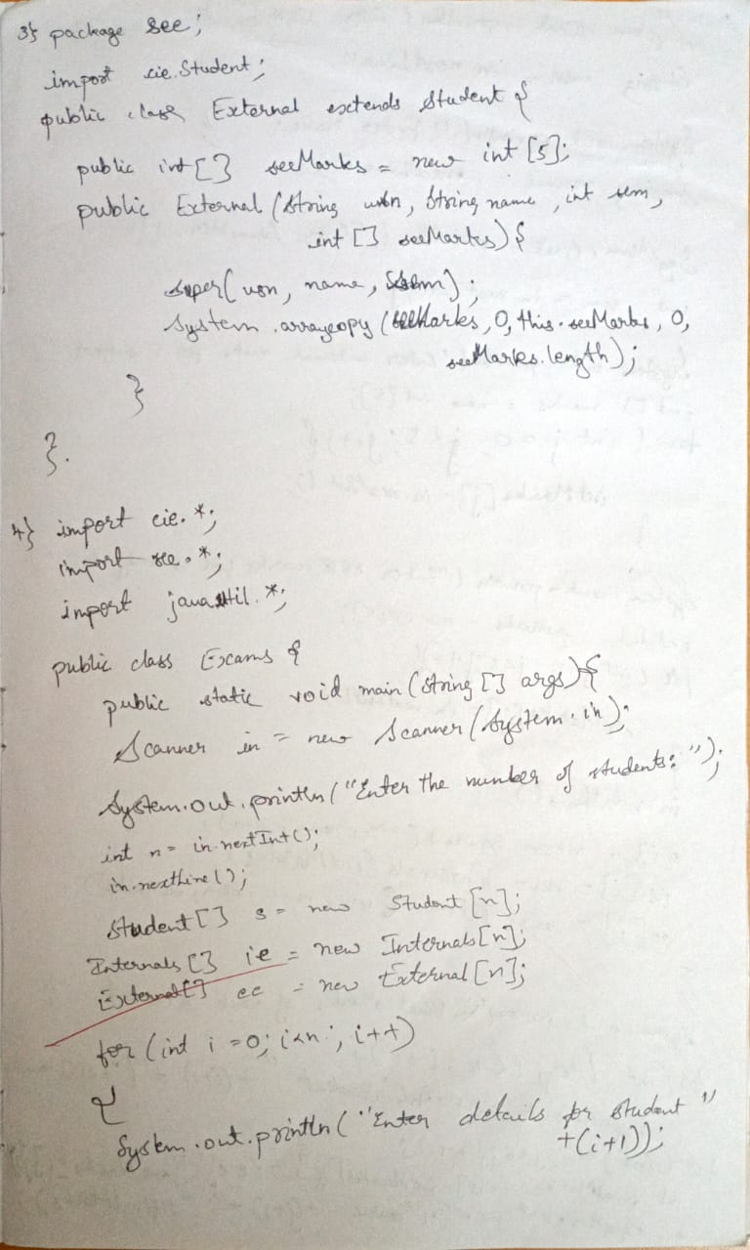

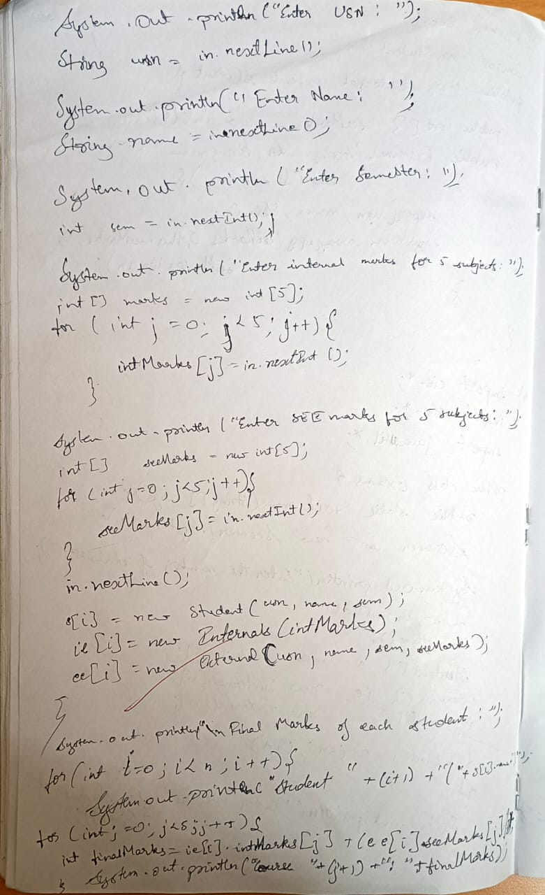

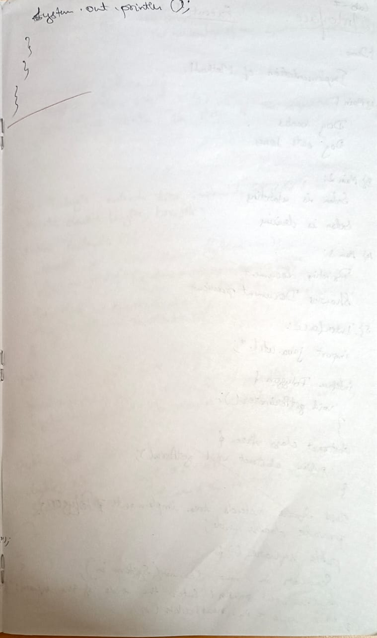

Screenshot: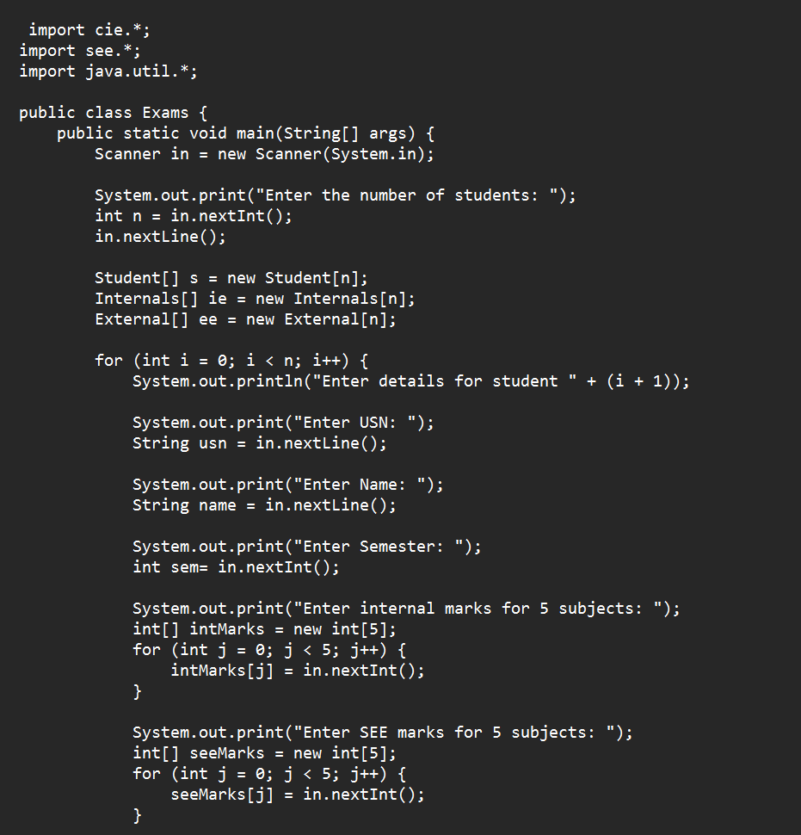

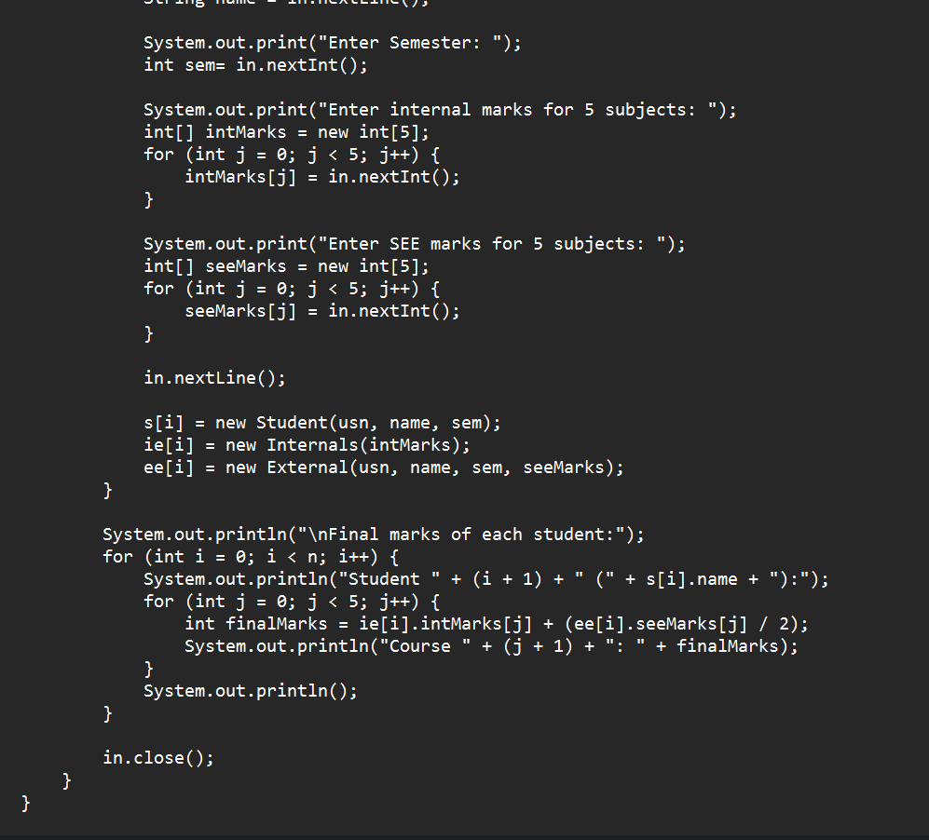

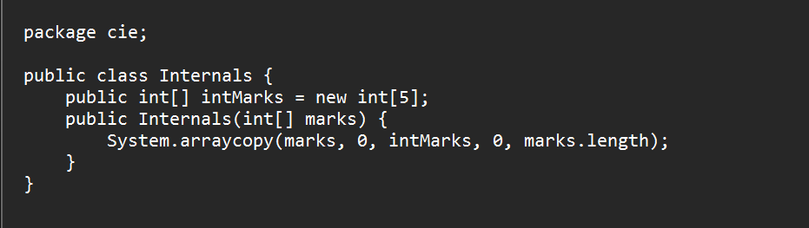

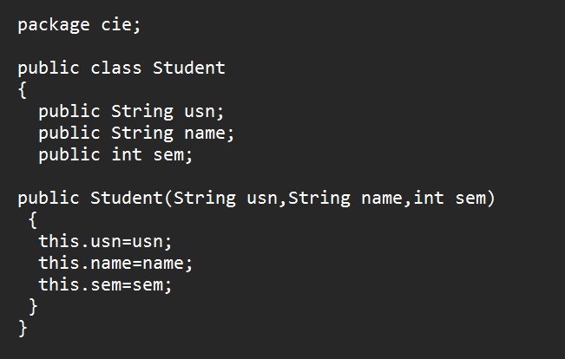

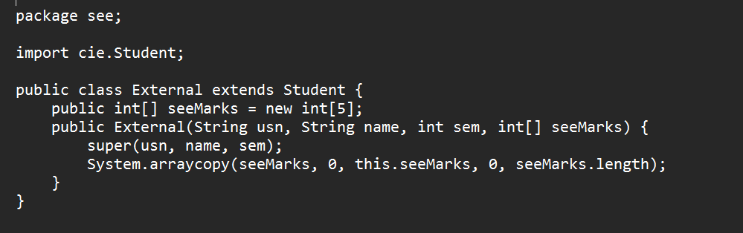

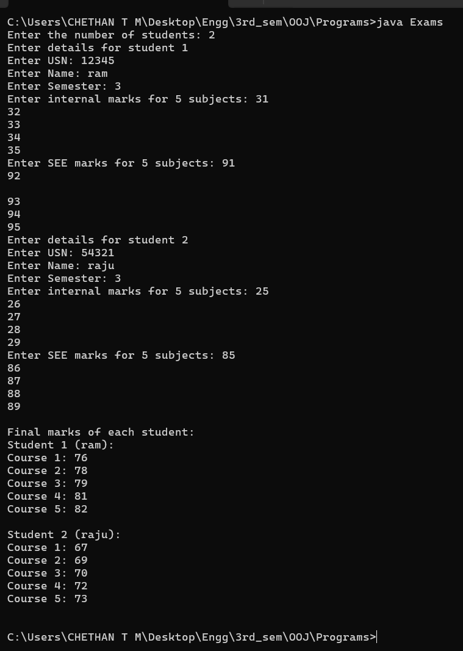

Program-7:

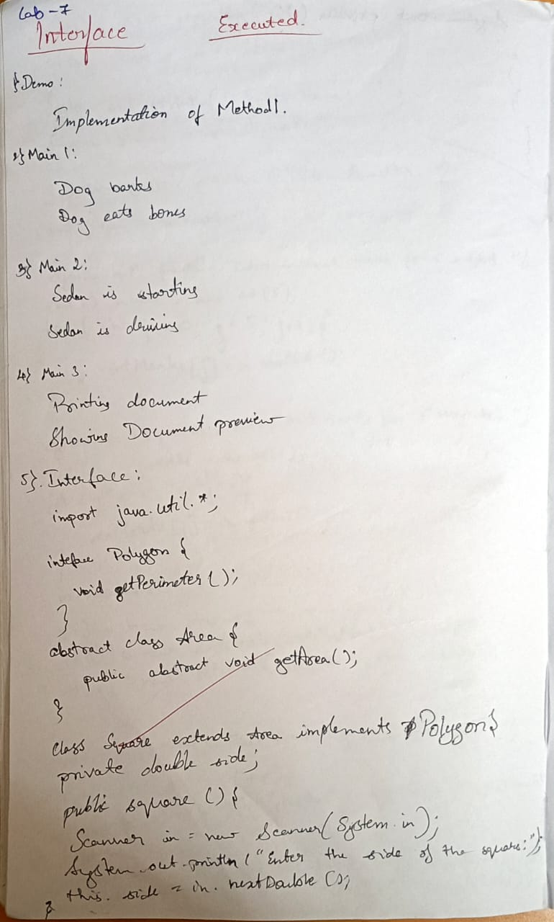

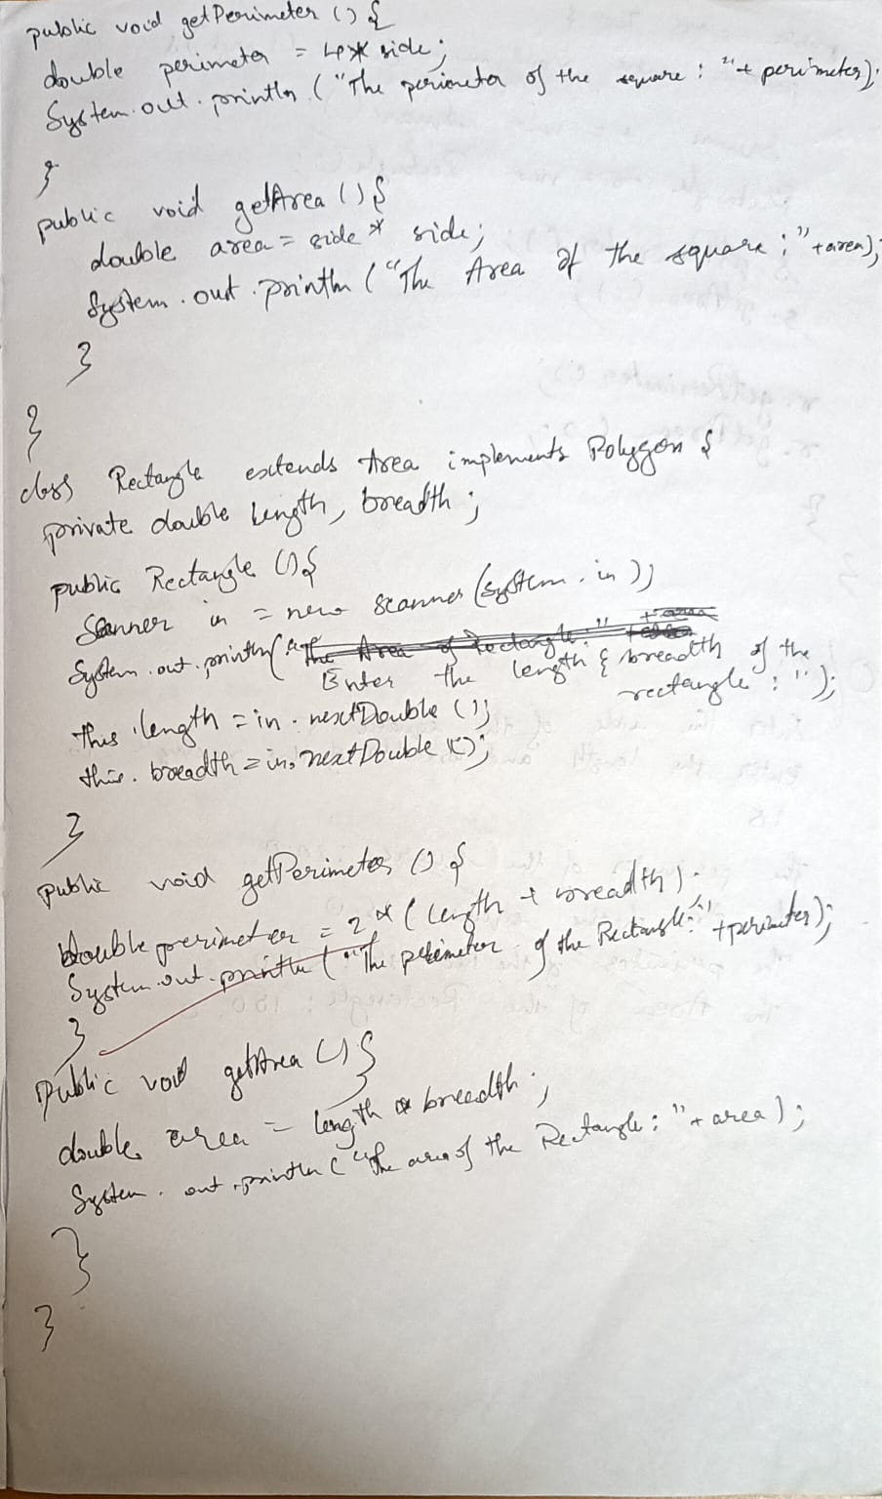

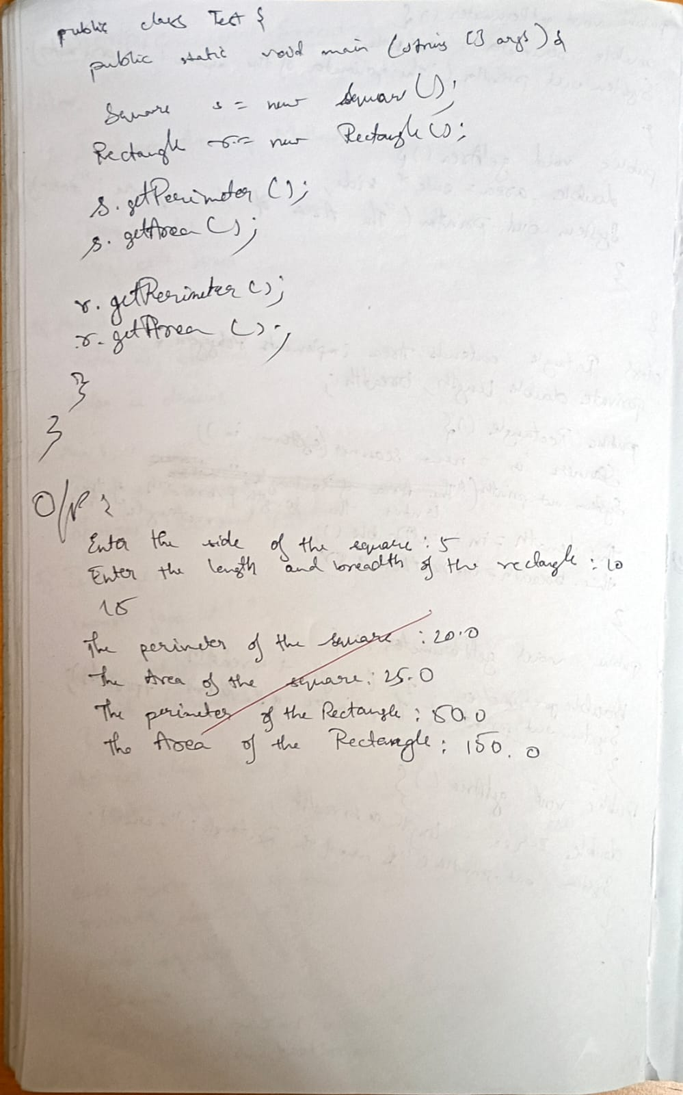

Screenshot:

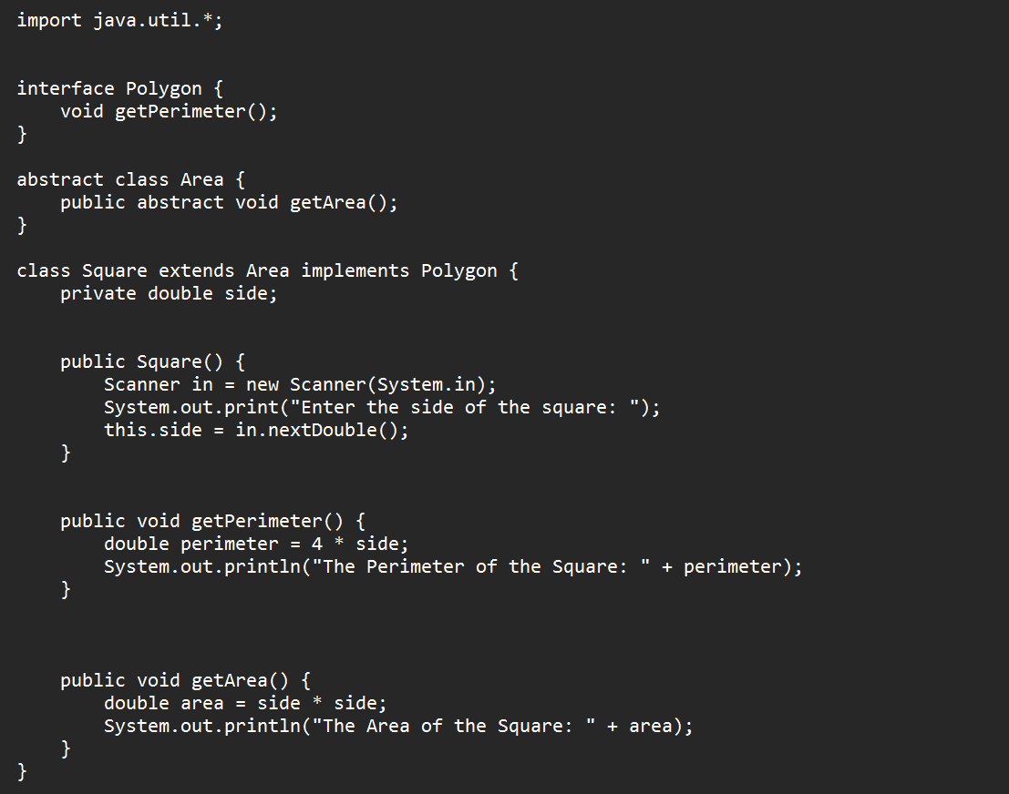

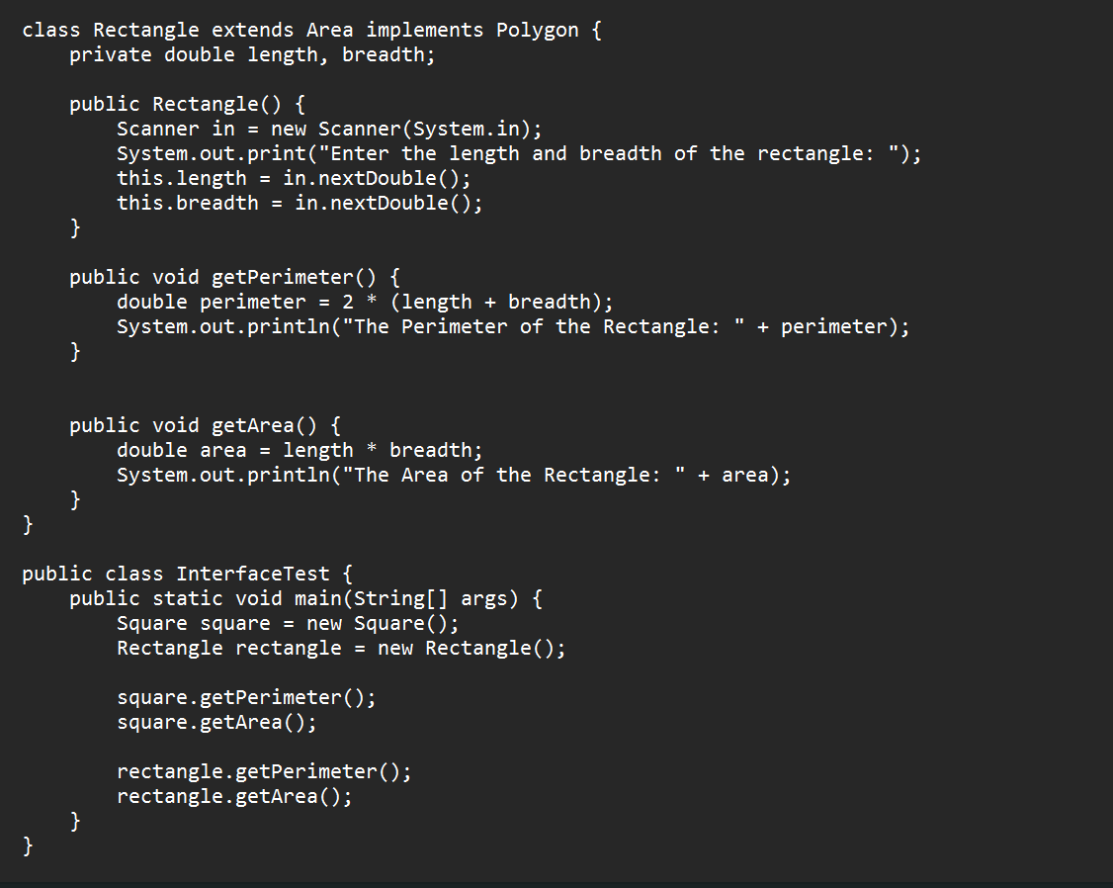

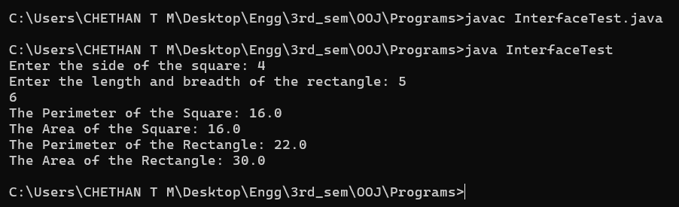

Program-8:

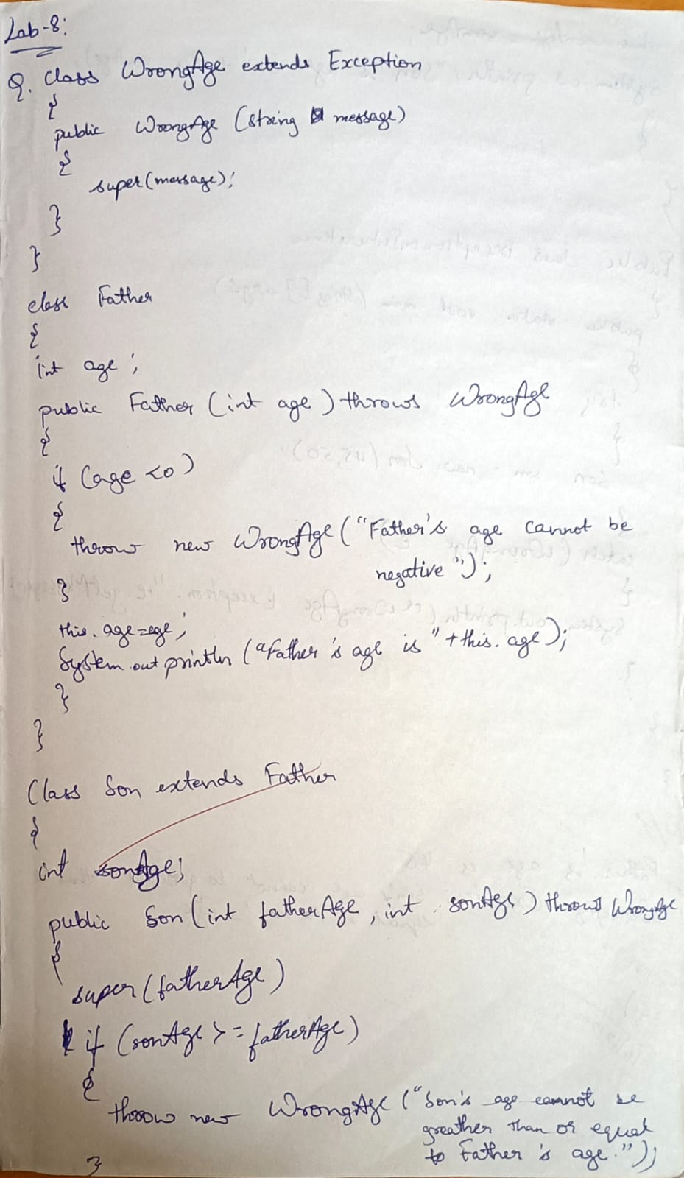

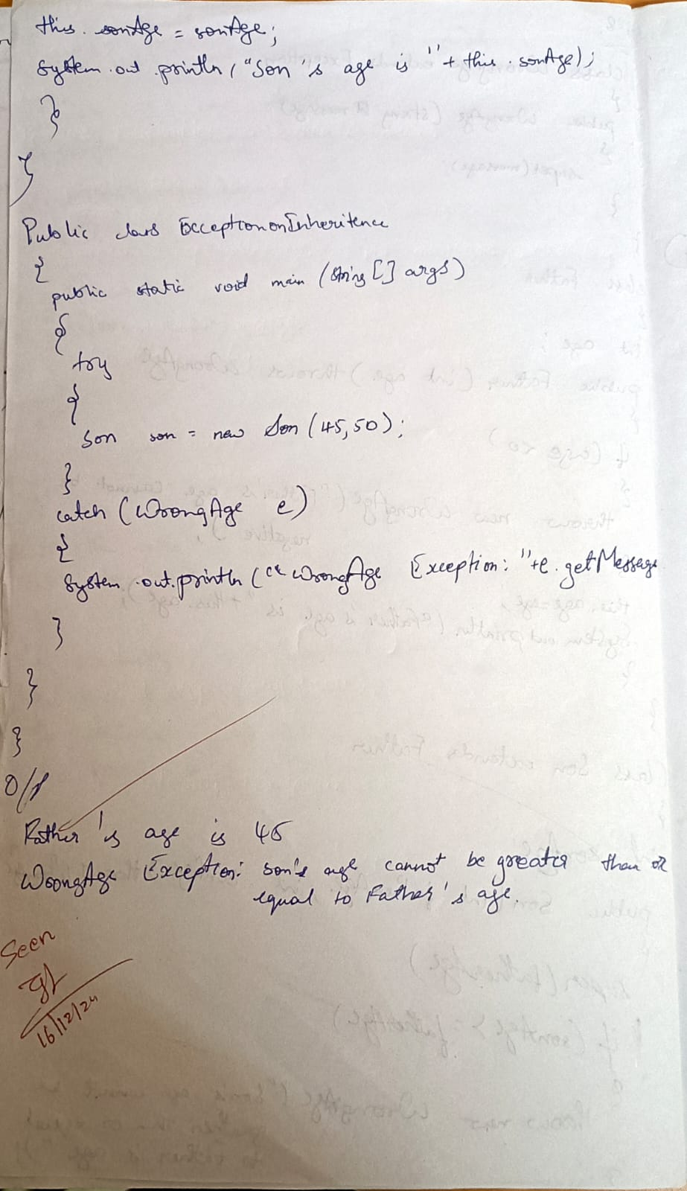

Screenshot:

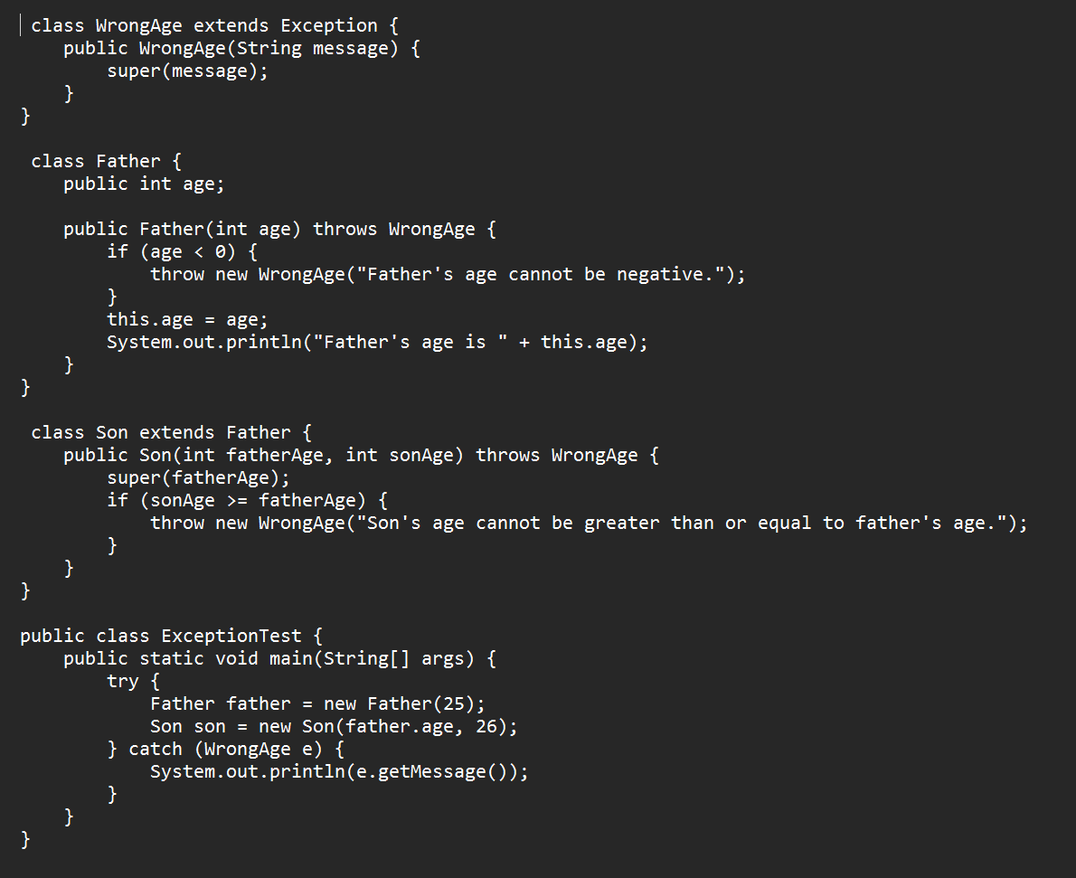

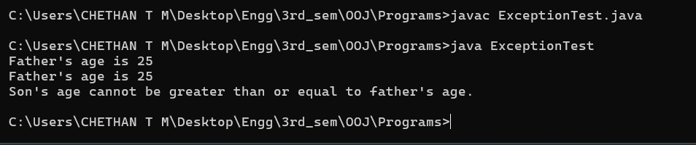

Program-9:

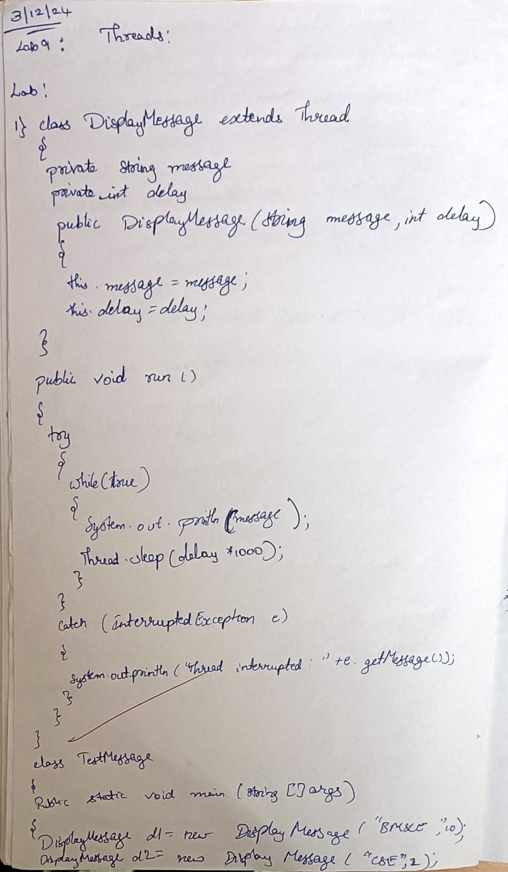

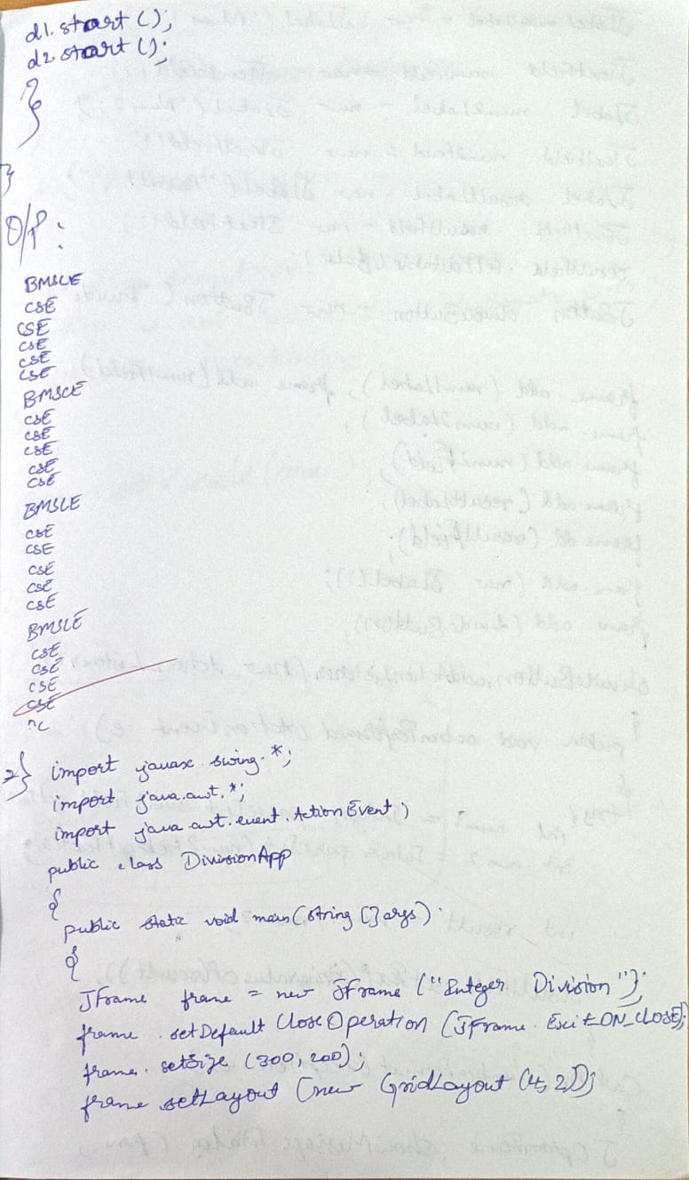

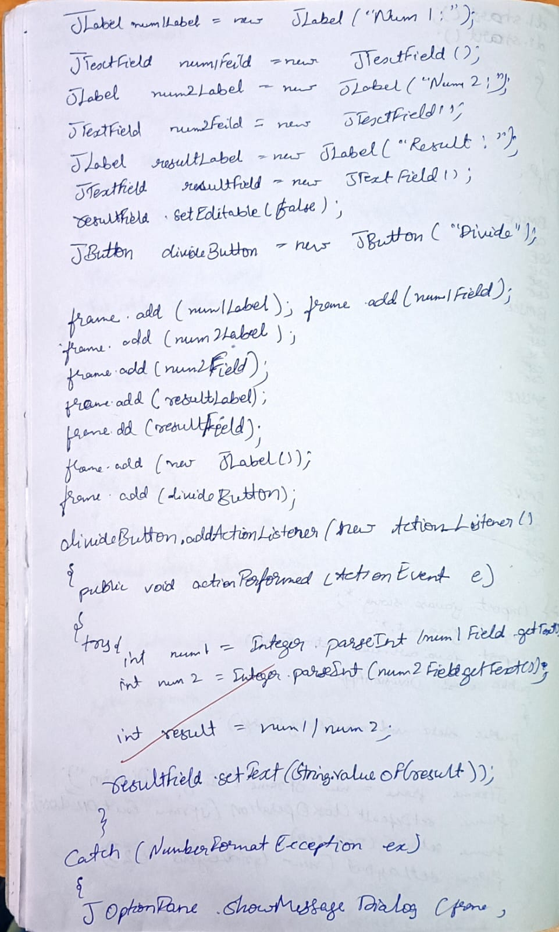

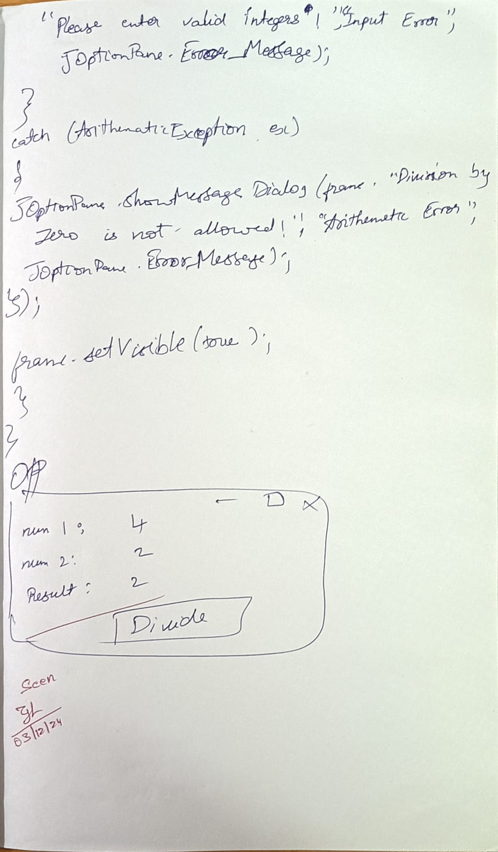

Screenshot:

